

Virtual Trade Mission to the Florida, USA

Delegation Brochure
Tuesday 12th November 24

Edinburgh Chamber of Commerce


Supported by


Edinburgh Chamber of Commerce, as part of the International Trade Partnership with the Scottish Government.

Edinburgh Chamber of Commerce (ECC)
The Edinburgh Chamber, Scotland’s capital city Chamber of Commerce, is an independent membership organisation which supports the business community in Edinburgh to grow and achieve success. Supporting over 850 organisations who employ more than 120,000 staff, we facilitate hundreds of connections every year and offer our members a rage of practical services and benefits.
In addition to hosting over 120 B-2-B events each year, the Edinburgh Chamber offers members a range of marketing opportunities, access to our exclusive Member Directory, discounted business training courses and support with internationalisation.
ECC International Department
Our programme provides international support, general export advice and information to help Scottish businesses to take the first step, as well as specific market information and case studies to help them decide where to take their business next. We have a busy calendar of trade missions to offer to both members and non-members of the Chamber. Our priority markets include Ireland, France, Spain, USA, Canada, China, Germany, Belgium, Norway, Poland and Sweden.

The Scottish Delegation
- RoslinCT
- Red Evolution Ltd
- Isle of Skye Distillers
- The Gaelic Whiskies
- LilyBee
- LS Productions
- Airc.digital
- Burns Gym Ltd
- Wardog Studios

RoslinCT 

Website: https://www.roslinct.com/

Representative: Andrew Paterson, Senior Business Development Manager

Sector: Life Sciences
RoslinCT’s mission is to save the lives of patients around the world, by empowering their partners to efficiently progress cell & gene therapies from development to commercialization, as their advanced CDMO partner of choice.

They offer their partners quality, agility, and flexibility as we advance their cell therapy products from development to commercialization. The RoslinCT purpose-built facilities in the UK and the US, our focus on innovation, and collective experience enable our partners to deliver cost-effective and compliant cell-based therapies to patients in need.

🔎 Looking for:
- Business leads for potential partners
- Contacts in the life sciences sectors particularly cell therapy developers

🌐 Exports Globally

Red Evolution Ltd Need logo
Website: https://marvellousmycology.com/
Representative: David Robinson, Managing Director
Sector: Creative Industries
Red Evolution is a full service digital marketing agency that helps engineering & tech companies create a growth-focused online presence. Offer industrial strength digital marketing for businesses that want to grow.
Companies who work with them because they are a plain-talking, get-the-job-done digital marketing agency with a reputation for creating and growing fantastic websites that generate enquiries for tech and engineering companies.
🔎 Looking for:
- Better understand how to secure more business in Florida.
- Market Knowledge
- Introductions to industrial, engineering, manufacturing and technology companies.

🌐 Exports to Australia and Europe

Isle of Skye Distillers Ltd 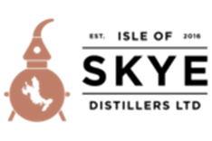
Website: www.isleofskyedistillers.com
Representative: Alistair Wilson, Managing Director
Sector: Food and Drink
Family owned and operated craft distillery based on the Isle of Skye distilling gin and vodka with a view to produce small quantities of Malt whisky within the next two years. Multi award winning range of craft gins and multi award winning vodka. In creating Misty Isle gin for example, the Wilsons took inspiration from the local landscape, the Old man of Storr, and the Cuillin mountain range in particular. With lots of dedication, burning the midnight oil, weeks foraging local juniper berries -often in the rain- they finally launched Misty Isle gin in early February 2017, to great applause.
All of the gins are made locally in Portree using the crystal clear spring waters from the Storr Lochs just over a few miles or so from the distillery. Initially launched as Isle of Skye gin, the Isle of Skye Distillery is able to boast the first stills producing gin on Skye.
🔎 Looking for:
- To find an importer and distributor
- Information on the legal elements of exporting to Florida
🌐 Export to Germany

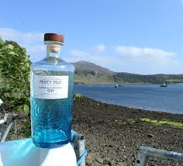

The Gaelic Whiskies 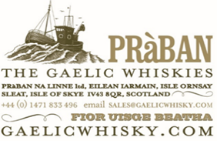
Website: www.gaelicwhisky.com
Representative: Roderick Mackenzie
Sector: Food and Drink
Pràban na Linne Ltd, proprietors of The Gaelic Whiskies, was founded on the Isle of Skye in 1976 by the late Sir Iain Noble. This independent spirits company has a strong Gaelic heritage, and is a longstanding supporter of the Gaelic language & culture in Scotland. Pràban’s principal Scotch Whisky brands are as follows:
• TÈ BHEAG (pronounced “chey vek”), is the colloquial expression used in Gaelic when requesting “a wee dram”, which is an exceptional connoisseur’s Blended Scotch Whisky, aged in sherry casks & with a high malt whisky content.
• MACNAMARA, which signifies “Son of the Sea”, is a lighter Blended Scotch Whisky, which is also available finished in Rum casks and Madeira casks.
• POIT DHUBH (pronounced “potch ghoo”), named after the Gaelic term for an illicit still, which is a range of fine Malt whiskies bottled at 8YO, 12YO & 21 Years Old, and specially selected Single Cask bottlings.
• The latest addition to our portfolio of premium spirits is the artisan Gin, UISGE LUSACH (pronounced “ooshka loosach”), meaning herbaceous spirit. Distilled in a traditional copper still, rumoured to have originally been used in the production of illicit whisky, UISGE LUSACH Gaelic Gin is available in three styles, Dry, Spiced and Sweet, as well as seasonal Gin liqueurs.
🔎 Looking for:
- Contacts for potential importers and / or distributors
🌐 Export to Canada, France, Germany, Austria, Netherlands, Switzerland, South Korea, Taiwan

LilyBee Ltd 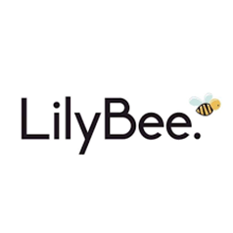
Website: https://www.lilybee.uk/
Representative: Robert Rennie, Consultant
Sector: Manufacturing & Retail
At LilyBee, they are dedicated to creating premium, all-natural skincare products while prioritising sustainability, ethical sourcing, and eco-friendly packaging. LilyBee offers a full line of all-natural skin care products that are created in Scotland using quality natural ingredients.
Their mission is to empower people to overcome the daily challenges of life using products which are natural and offer an alternative to synthetic ingredients.
All of the products are UK certified and registered and all of the products have been independently tested by a registered cosmetic chemist recognised in accordance with UK law In the United Kingdom (UK), the manufacture of cosmetics is governed by the EU Cosmetics Regulation ((EC) No. 1223/2009).
🔎 Looking to:
- Find partners/distribution or retailers to distribute and sell their products
🌐 Export to Ireland, Norway and Hong Kong

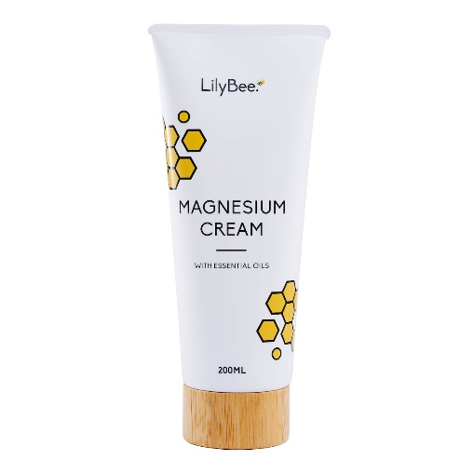

LS Productions Global Ltd
Website: https://lsproductions.com/
Representative: Karen Andre, Sales and Marketing Director
Sector: Creative Industries
LS Productions are a global production partner providing expert knowledge on commercials, film and TV, music videos, fashion and sports projects. Their team of creative collaborators and problem-solvers work from their production hubs in Edinburgh, Manchester and London, and warm water location in Malta.
Clients include Adidas, Anonymous Content, BMW, Havas, HBO, Netflix, Porsche, Pulse Films, Ralph Lauren, Rogue Films, Stink Films, Somesuch and Vogue.
🔎 Looking to:
- Market intelligence
- Contacts in film & TV production companies in Florida

🌐 Export to Boston and Los Angelas


Airc.digital
Website: https://www.airc.digital/bim
Representative: Pierre Saunal, Studio Management Lead
Sector: Construction
Building Information Modelling (BIM) consultants for the construction sector. This includes 3D modelling, information management, Archicad related templates, workflows and learning content, bespoke design tools and BIM management of construction projects. They work with and for architects, developers, contractors, public bodies, energy consultants and virtually everyone in the construction sector.

🔎 Looking for:
- Establish closer links with local businesses and official organisations to develop further a local presence leading to a potential partnership with a similar local practice.
- Introduction to Architects, construction and infrastructure companies
🌐 Export to Middle East, North Africa and Europe

Burns Gym Ltd 
Website: www.burnsgym.com
Representative: Joe Burns, Director
Sector: Leisure
Burns Gym offer personal training services tailored on a one-to-one and group basis, perfect for those seeking more personalised guidance and support in their based studio. They also provide an evidence-based online community care home fitness programme which is delivered weekly to several hundred care homes.

They bring passion, energy, and expertise to every session, emphasising not just physical health but also mental well-being .The programme is purposely built for older adults, whether living independently or in care homes, enabling them to engage in workouts alongside family members, loved ones, and care home staff.

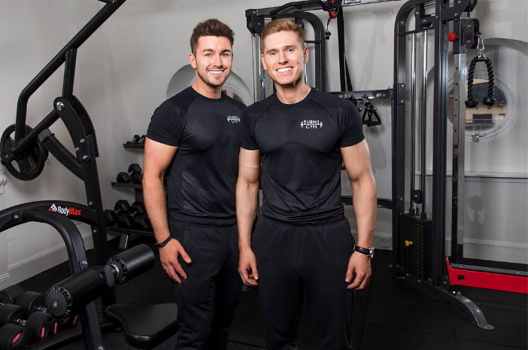
🔎 Looking for:
- Insights into the local Florida market and information on the regulatory requirements.
- Explore opportunities for expanding their virtual fitness programme into Florida.
- Contacts in care homes.

Wardog Studios 
Website: https://www.wardog.co/
Representative: Scott Baxter, Operations Director
Sector: Creative Industries

Wardog Studios is a premier art development studio with a global reputation for providing best in industry weapons and vehicles for games and film. Based in Edinburgh in the UK, they provide international AAA clientele with concept art and 3D Assets.
They operate as fully supportive external art development team so their abilities don’t just end with creating world leading art. They understand technical pipelines, cutting edge technology and can also advise on workflows and integration for achieving the best possible presentation
Wardog has the skill and passion to provide the highest quality asset development available that supports the needs and ambition of their clients. Weapons, props, vehicles, they can build it!
They can support each stage of clients’ production cycle, from initial concept art through to the production of real-time in-game assets. Their team of industry leading artists can provide full integration services for PC, Consoles and VR-platforms.
🔎 Looking for:
- Contacts in the creative industries
- Contacts in games development

